**EXPERINMENT 7 & 8**

**Aim :** Learn different filters and apply on image and also learn 1D DFT and IDFT.

* **Exercises :**

1. **Implement homomorphic filter and apply it to your photo with pepper noise, salt noise and salt and pepper noise. Conclude the results.**

Code :

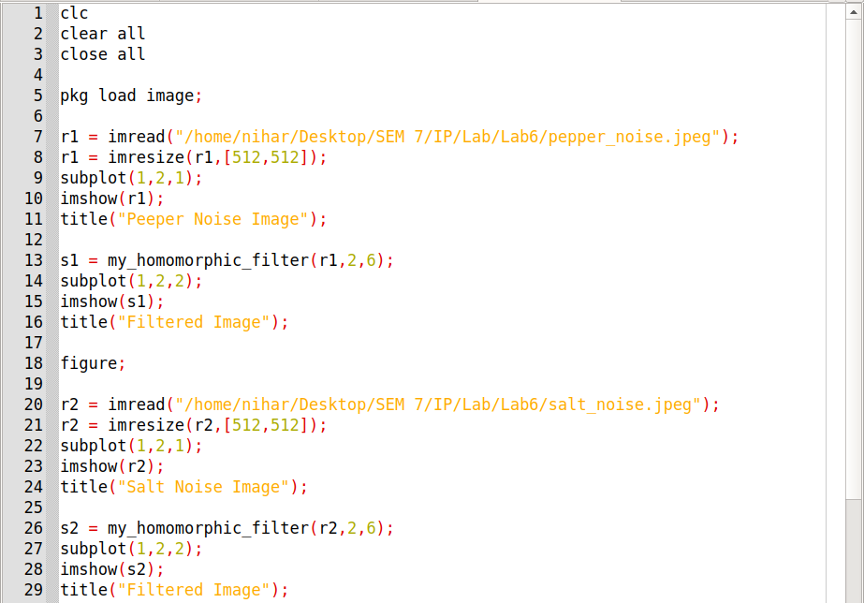

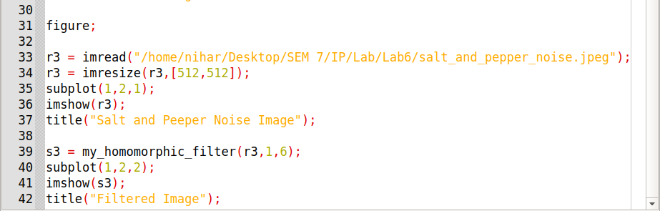

Function for Homomorphic Filter :

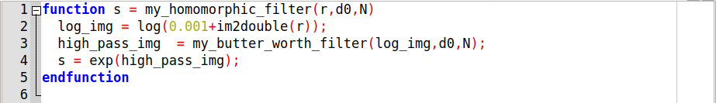

Function for Butter Worth Filter :

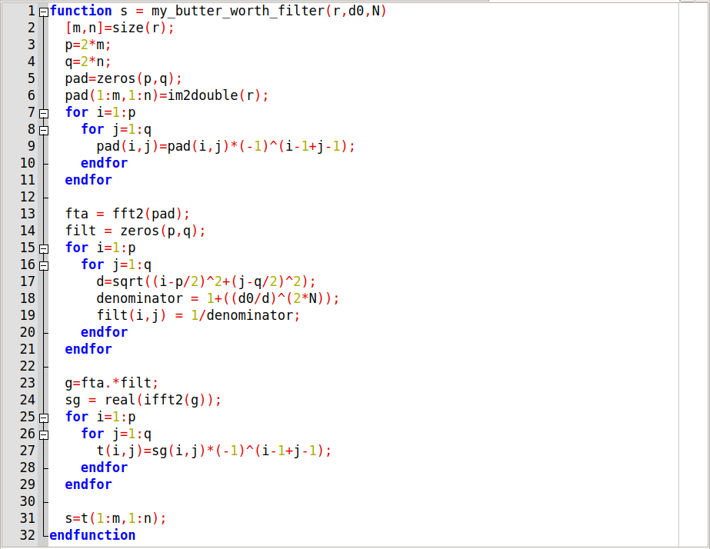

* Output of homomorphic filter depends on filter and value of parameters like d0, n(order of filter) and type of fitler.
* In my case image get overexposed so it can be used for low exposed image to enhance.

Output :

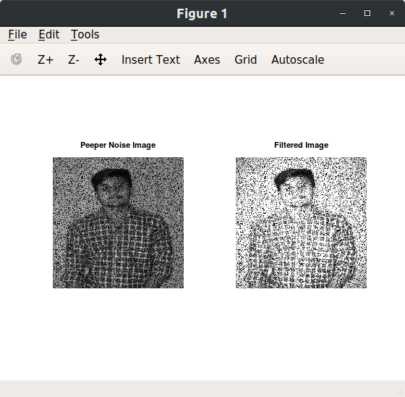

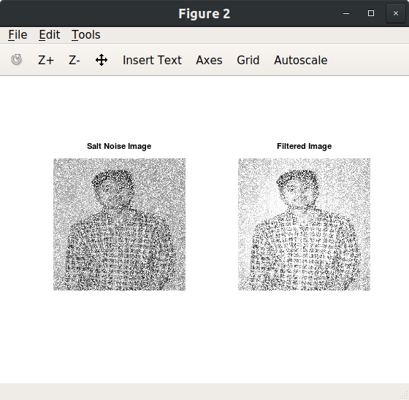

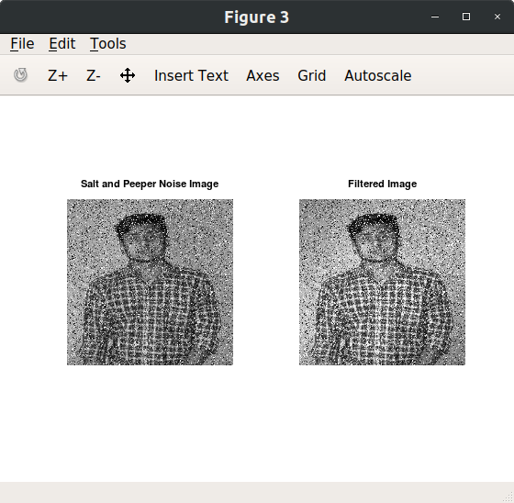

1. **Use contra harmonic filter with Q +ve value for salt noise, pepper noise and salt and pepper noise. Comment on your outcome.**

* **Solution :-**
* For positive value of Q it removes pepper noise and increase noise for salt.
* For salt and pepper noise image is giving same effect as salt image because it has both salt and pepper noise. Pepper is noise is reduced but salt noise is increased.

Code :

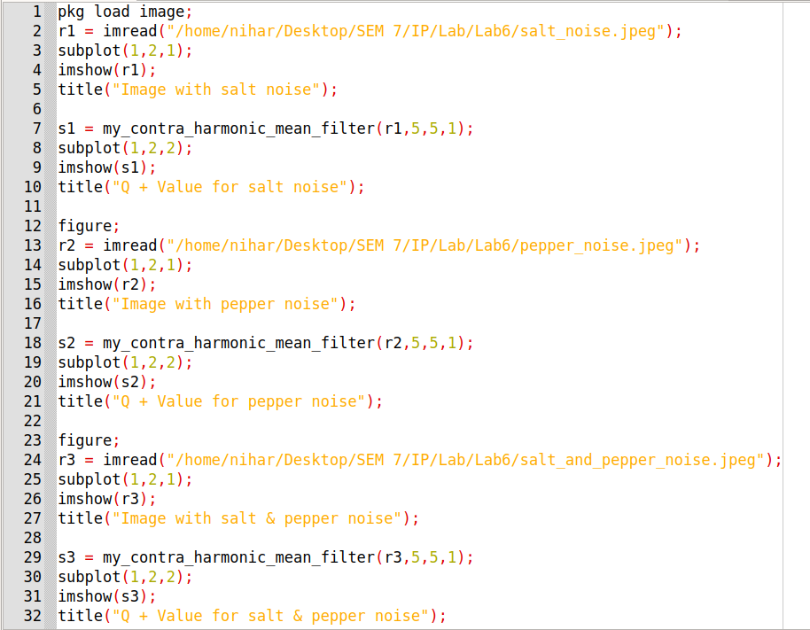

Function for Contra Harmonic Filter :

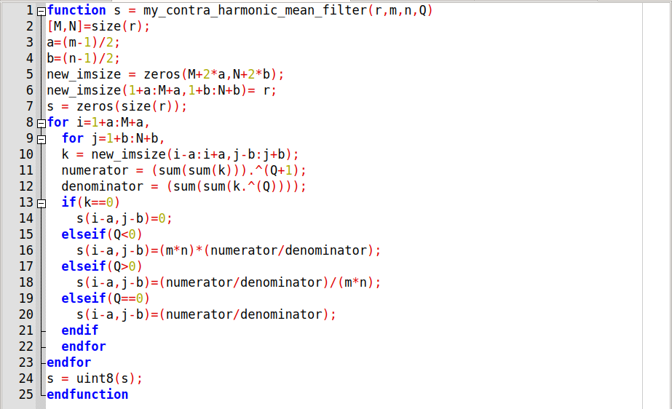

Output :

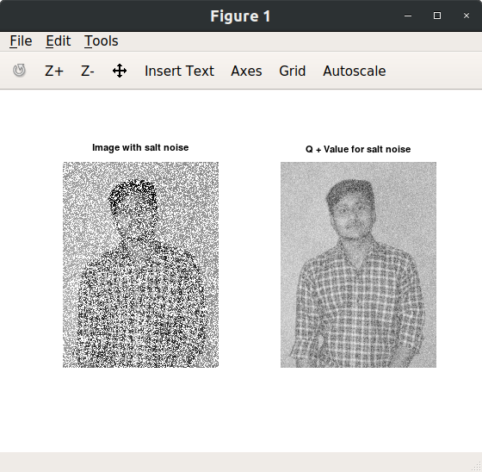

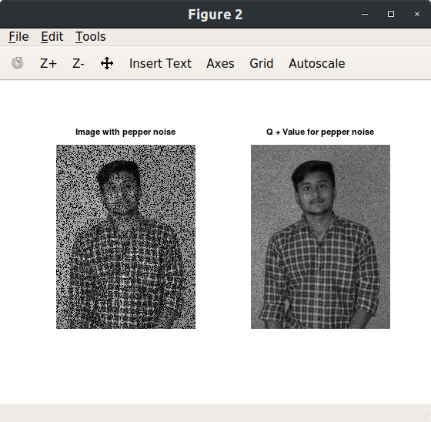

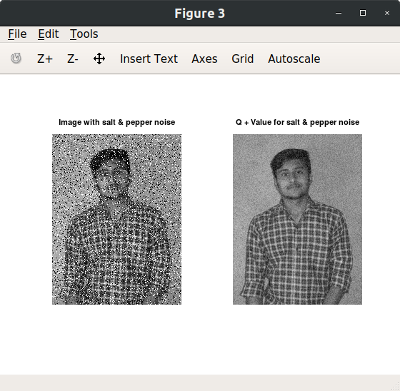

1. **Use contra harmonic filter with Q values –ve for value for salt noise, pepper noise and salt and pepper noise. Comment on your outcome. .**

* **Solution :-**
* For negative value of Q it reduces salt noise and increases pepper noise.
* For salt and pepper noise image it increases pepper noise and decrease salt noise.
* For salt and pepper I passed first with negative Q value and then on that result positive Q valued contra harmonic filter is applied so noise get reduced.

Code :

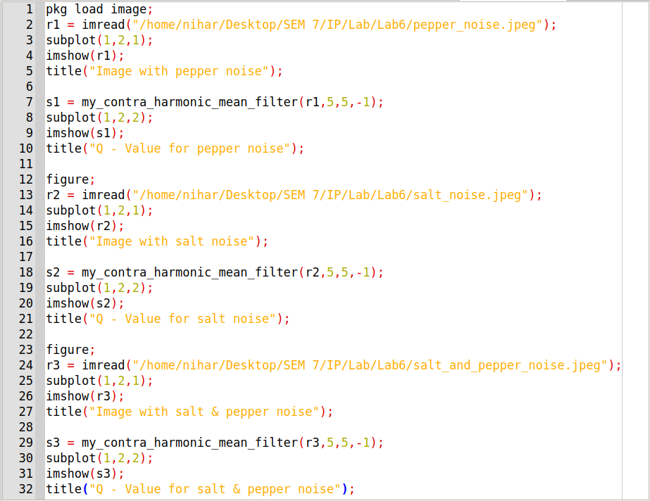

Output :

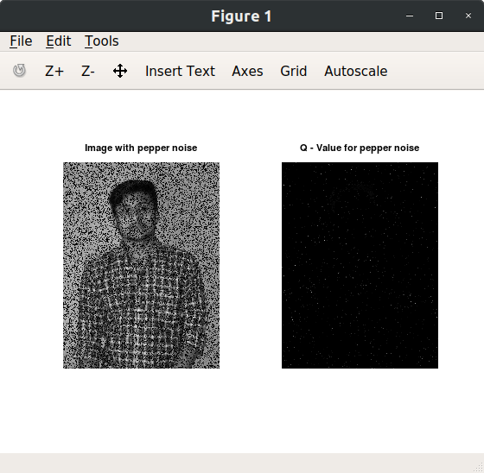

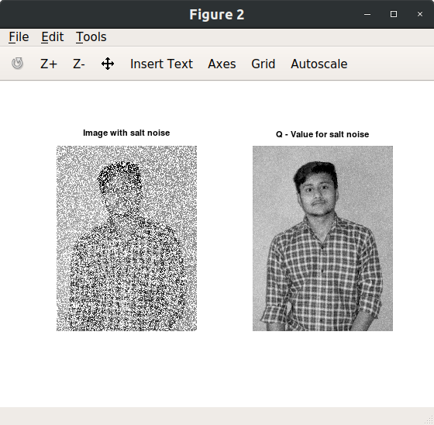

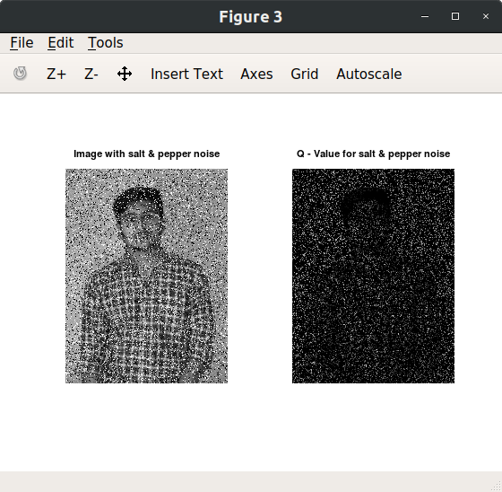

1. **If Q value is taken zero in contra harmonic filter it will be suitable for which kind of noise? Why? Justify your answer by implementation and results.**

* **Solution :-**
* For Q = 0 contra harmonic filter behaves like arithmetic mean filter(it’s equation becomes like arithmetic mean filter).
* so it is suitable for local variation in image(I used image with gaussian noise) so via blur noise is reduced.

Code :

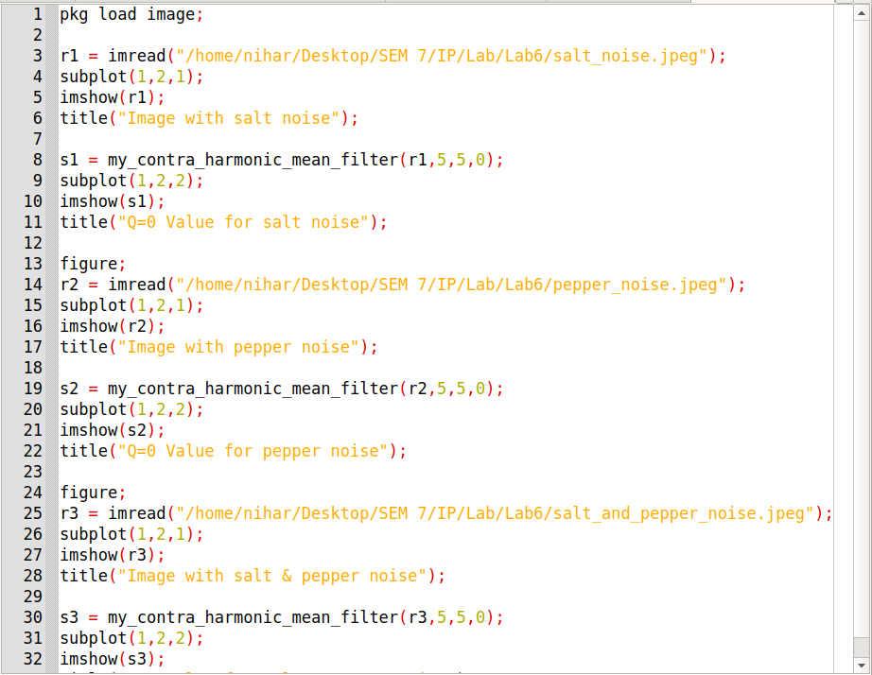

Output :

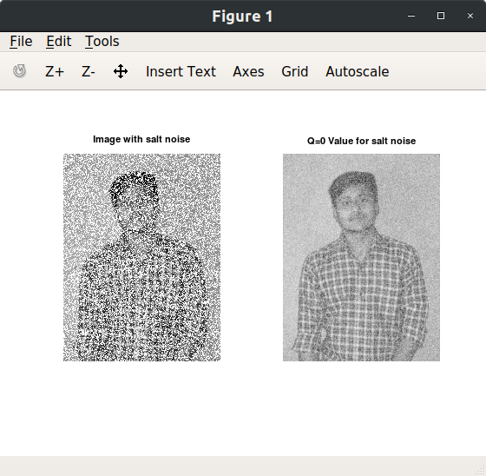

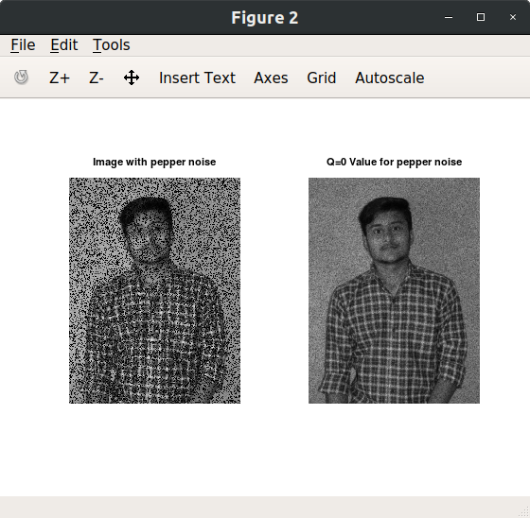

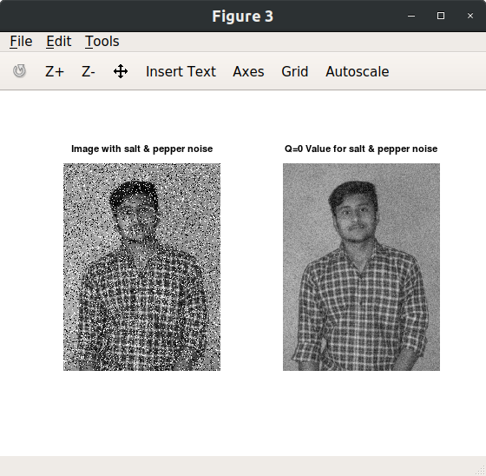

1. **Apply arithmetic mean filter and geometric mean filter of various size to noisy image. Compare geometric mean filter and arithmetic mean filter in terms of blurring.**

**Original image contains gaussian noise.**

**For filter size = 3(left image applied applied arithmetic filter and right image geometric filter).**

* **Solution :-**
* Geometric filter achieves smoothing comparable to arithmetic filter and but it tends to loss less image detail in process.

Function for Arithmetic Mean Filter :

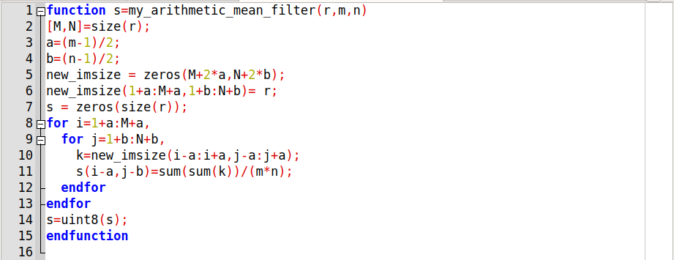

Function for Geometric Mean Filter :

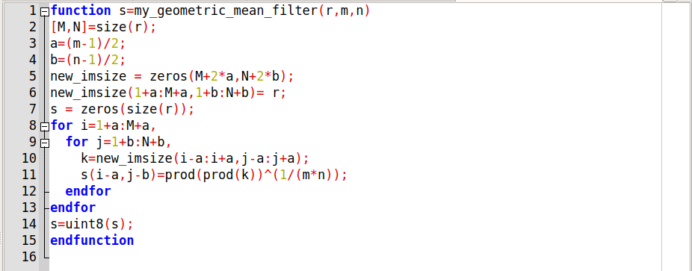

Code :

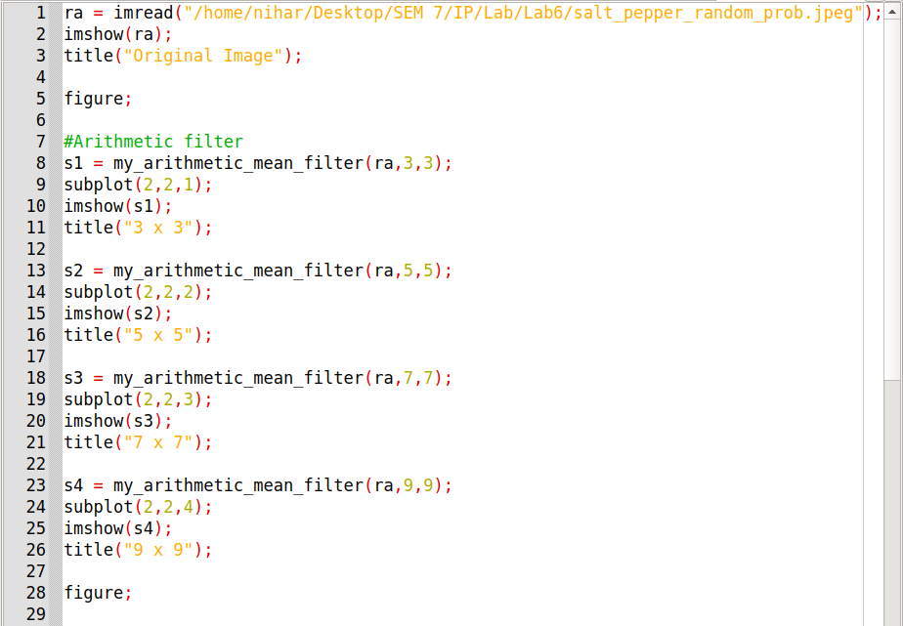

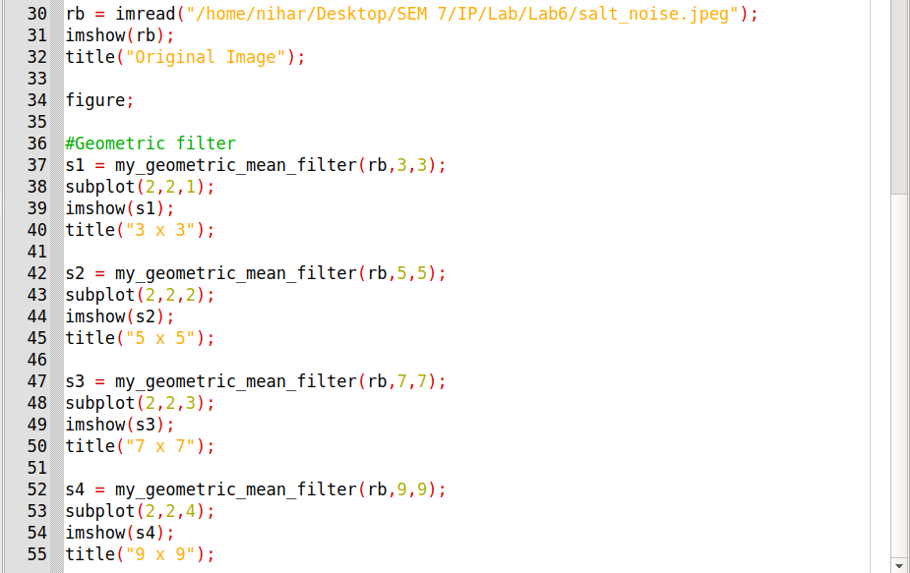

Output :

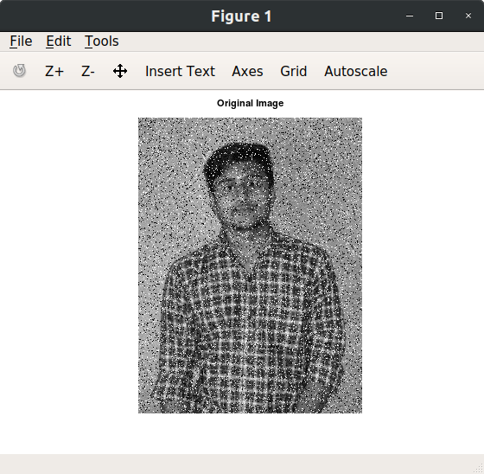

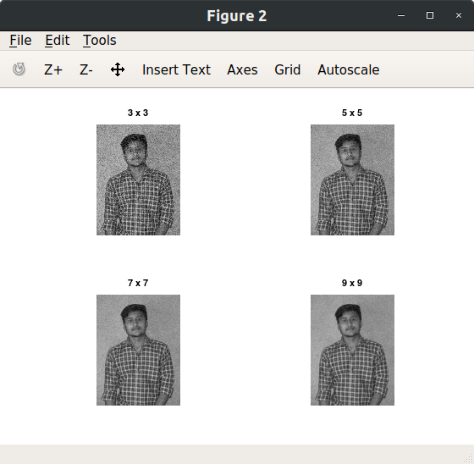

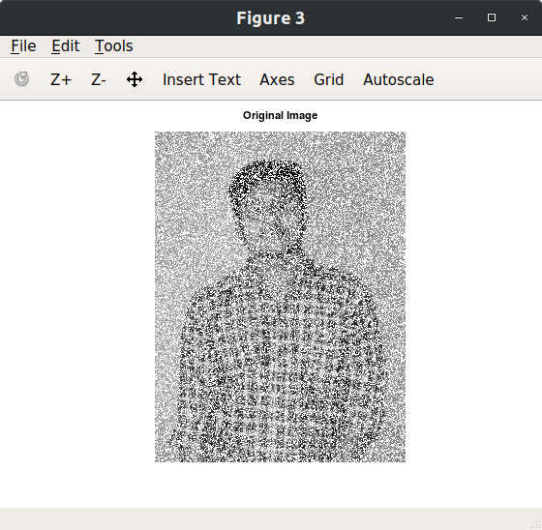

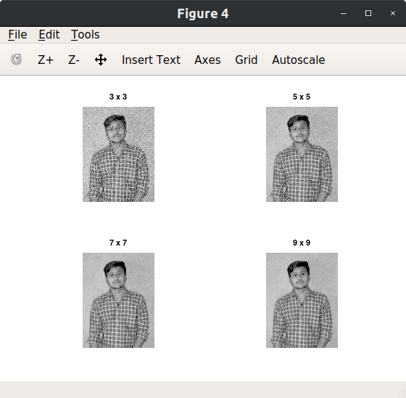

1. **Implement Adaptive median filter. compare the results with median filter and comment on the outcome. (original image(salt and pepper noise) – median filter ---- adaptive median filter).**

* **Solution :-**
* Median filter works good for salt and pepper noise but looses details while adaptive median filter maintains details.

Code :

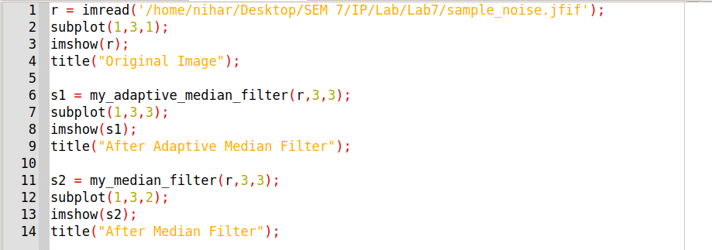

Function for Median Filter :

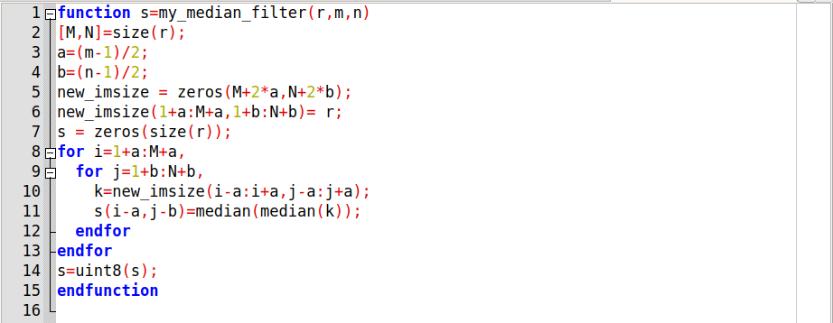

Function for Adaptive Median Filter :

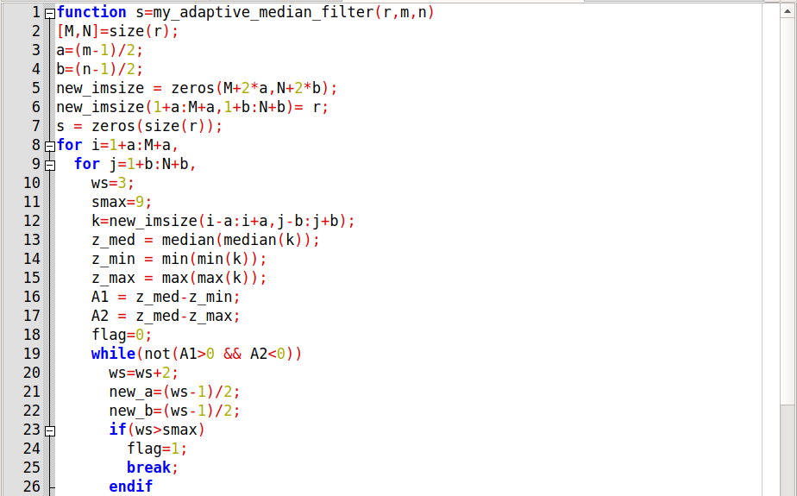

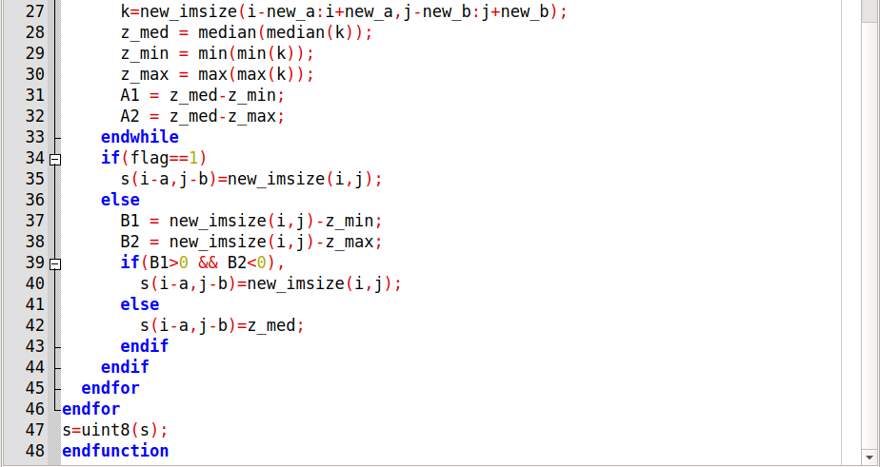

Output :

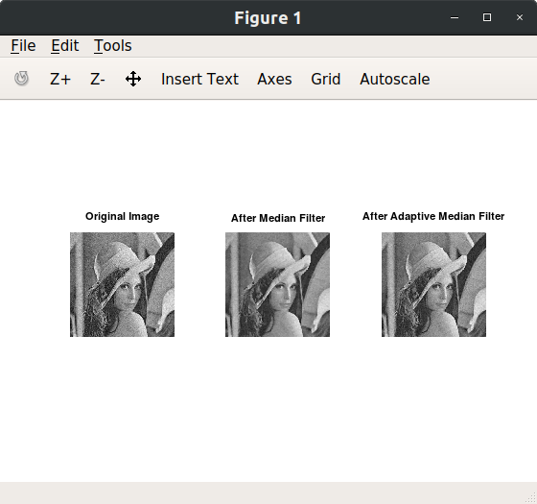

1. **Implement mid point filter and apply it on your photo with Gaussian noise.**

* **Solution :-**

Code :

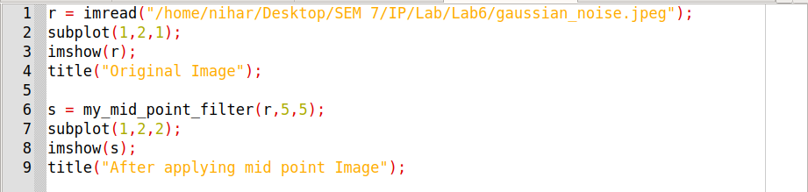

Function for Mid Point Filter :

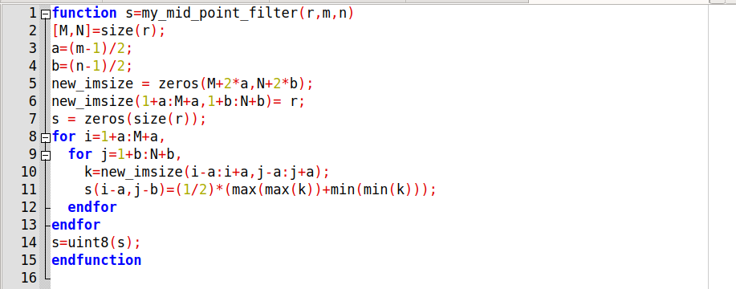

Output :

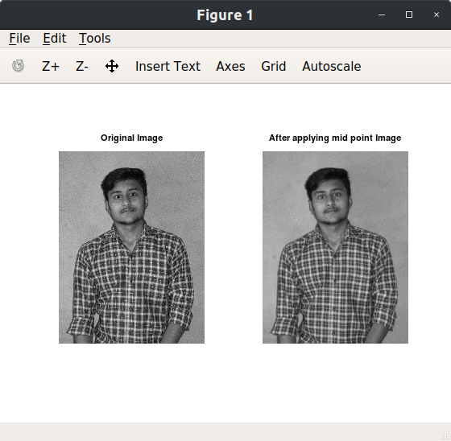

1. **Take your photo with salt and pepper noise (probability 0.4) and Apply multiple passes of median filter and conclude about the outcome and blurring. Also apply median filter of different size (3x3, 5x5,7x7) comment on the outcome.**

* **Solution :-**
* Multiple passes of median filter helps for reducing salt and pepper noise. In each iteration it will reduce noise.
* More the size of median filter more the salt and pepper noise is reduced.

Code :

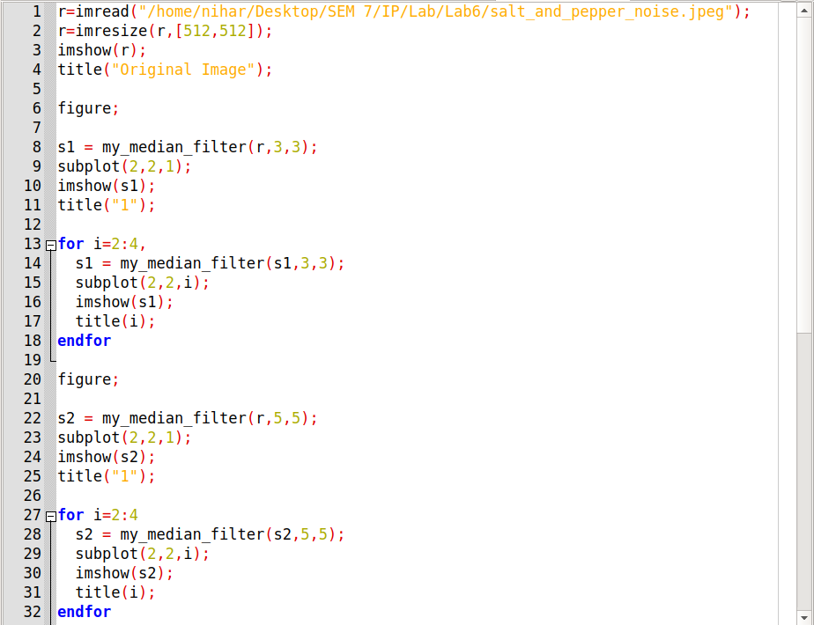

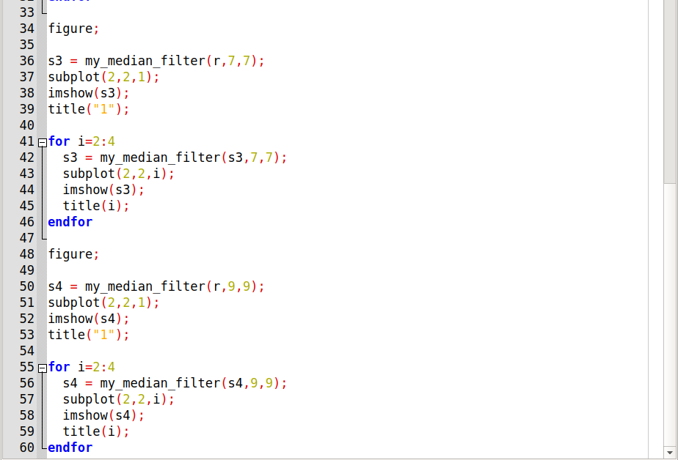

Output :

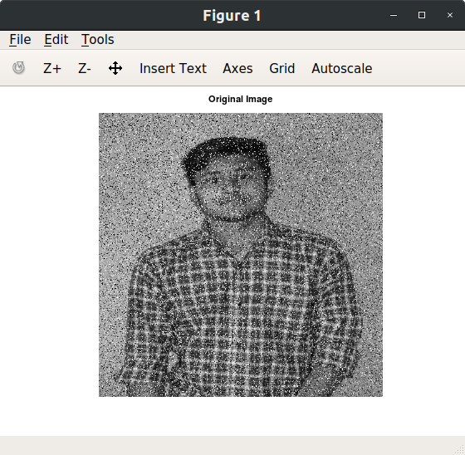

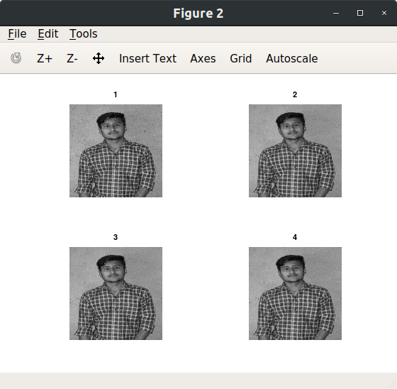

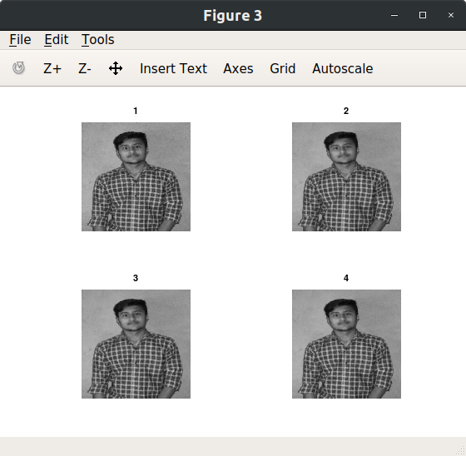

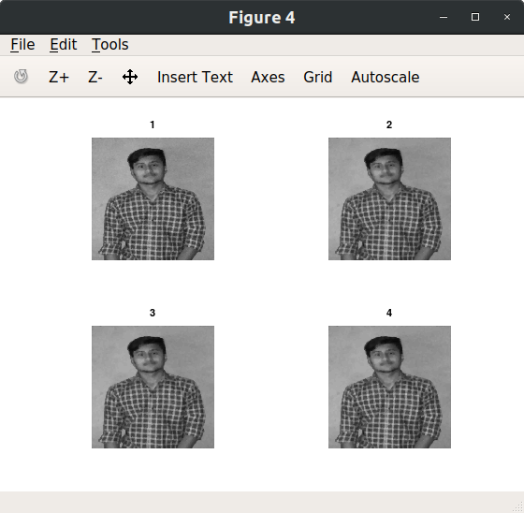

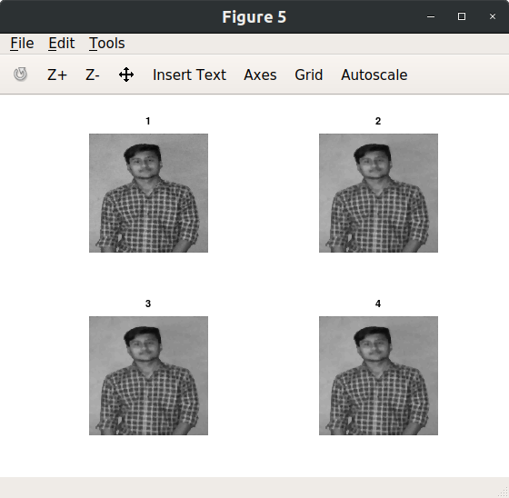

1. **Take your photo with Gaussian noise and apply median filter over it. Comment on the outcome.**

* **Solution :-**
* Median filter is effective for bipolar and unipolar noise.
* it has good effect on gaussian noise image too.

Code :

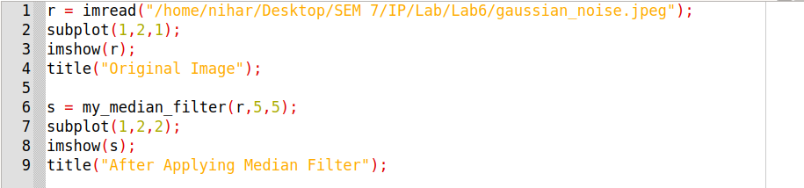

Output :

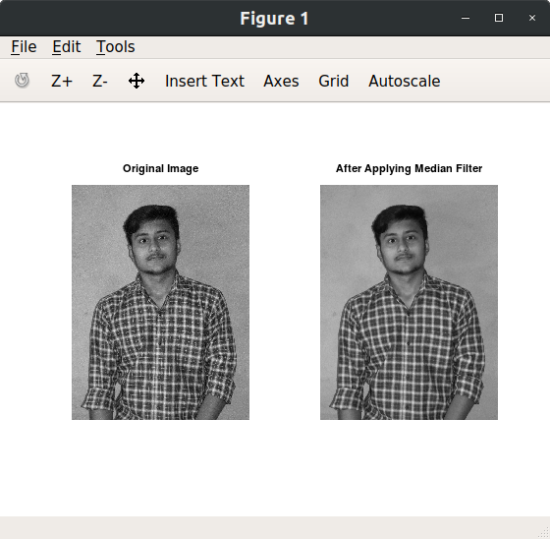

1. **Implement 1-D Discrete Fourier Transfom and Inverse Discrete Fourier Transform.**

* **Solution :-**

Code :

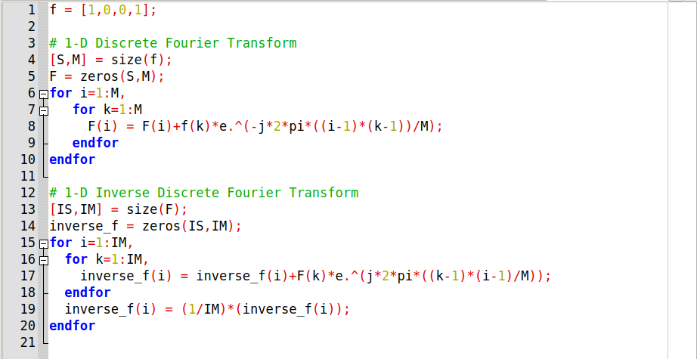

Output :

